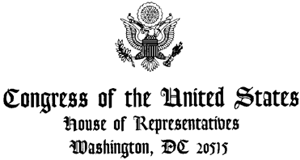

FOR IMMEDIATE RELEASE
October 18, 2019
Schakowsky, Johnson, Jayapal and Pocan Issue Statement on Honduras

WASHINGTON, DC – Leaders of the Congressional Progressive Caucus - Representatives Jan Schakowsky, Hank Johnson, Pramila Jayapal and Mark Pocan - issued the following joint statement regarding corrupt government regime in Honduras:

“The Trump Administration must end its support of the repressive and corrupt Honduran regime of Juan Orlando Hernández. The Honduran President’s brother and former congressman, Antonio ‘Tony’ Hernández, was arrested and convicted in the United States for conspiring to import cocaine into the U.S. and possessing illegal weapons. In the past two weeks, witness after witness at his New York trial has testified that murderous drug traffickers, including Joaquin ‘El Chapo’ Guzman, gave President Hernández more than $2 million to support his electoral campaigns in exchange for protection.

“A prominent drug trafficker testified that Tony Hernández bribed the current Minister of Security, Julian Pacheco Tinoco, who oversees the police. Another testified that he paid bribes to make sure that an alleged death squad member, Juan Carlos “El Tigre” Bonilla, was placed in a high position under presidents Lobo and Hernández at Hernández’s behest and described a murder Bonilla committed at their request. Bonilla became National Director of the Police, and yet despite evidence that he was a documented death squad leader, the U.S. Embassy worked closely with Bonilla throughout his term. The Trump Administration must immediately stop funding the corrupt Honduran police and military and stop celebrating President Hernández as a friendly ally and partner in the drug war.

“The U.S. should stop banning Honduran migrants who are trying to flee this terror within their home country. We need to condemn the Honduran government’s continued use of live bullets and poisonous tear gas to disrupt opposition protests and call for an end of its criminalization of dissent by grassroots environmental defenders - such as those from Guapinol. That is why 74 Members of Congress and counting support H.R. 1945, the Berta Cáceres Human Rights in Honduras Act, which calls for an immediate suspension of U.S. funding for Honduran security forces until their government investigates, and brings to justice, perpetrators of violence and unrest in Honduras.”

###

Miguel A. Ayala
Communications Director
Rep. Jan Schakowsky
2367 Rayburn HOB
Washington, D.C. 20515
P: 202-225-2111; C: 202-374-1098
http://schakowsky.house.gov

